Intel iPaat Module 3: IAM Policies Assignment Contact us: support@intellipaat.com / © Copyright Intellipaat / All rights reserved Intel iPaat AWS Solutions Architect Training Problem Statement: You work for XYZ Corporation. To maintain the security of the AWS account and the resources you have been asked to implement a solution that can help easily recognize and monitor the different users. Tasks To Be Performed:

1. Create policy number 1 which lets the users to:

a. Access S3 completely

b. Only create EC2 instances

c. Full access to RDS

2. Create a policy number 2 which allows the users to:

a. Access CloudWatch and billing completely

b. Can only list EC2 and S3 resources

3. Attach policy number 1 to the Dev Team from task 1

4. Attach policy number 2 to Ops Team from task 1

**1. Created policy number 1 which lets the users to:**

**a. Access S3 completely**

**b. Only create EC2 instances**

**c. Full access to RDS**

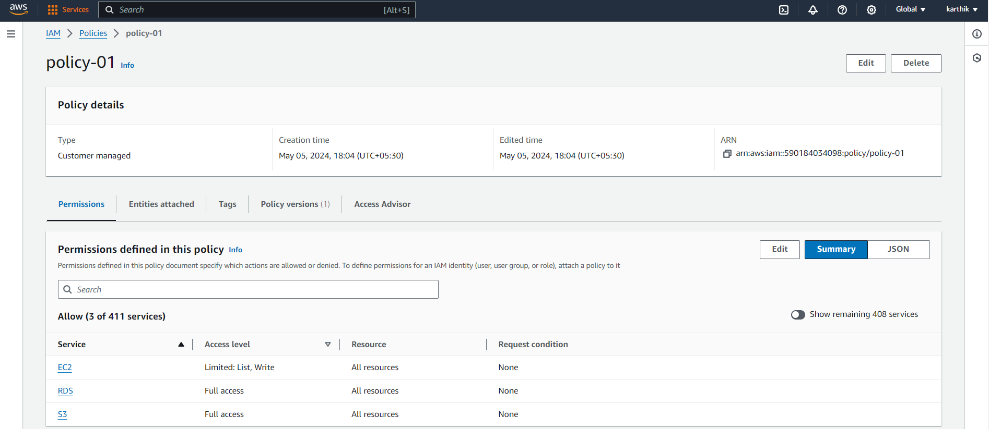

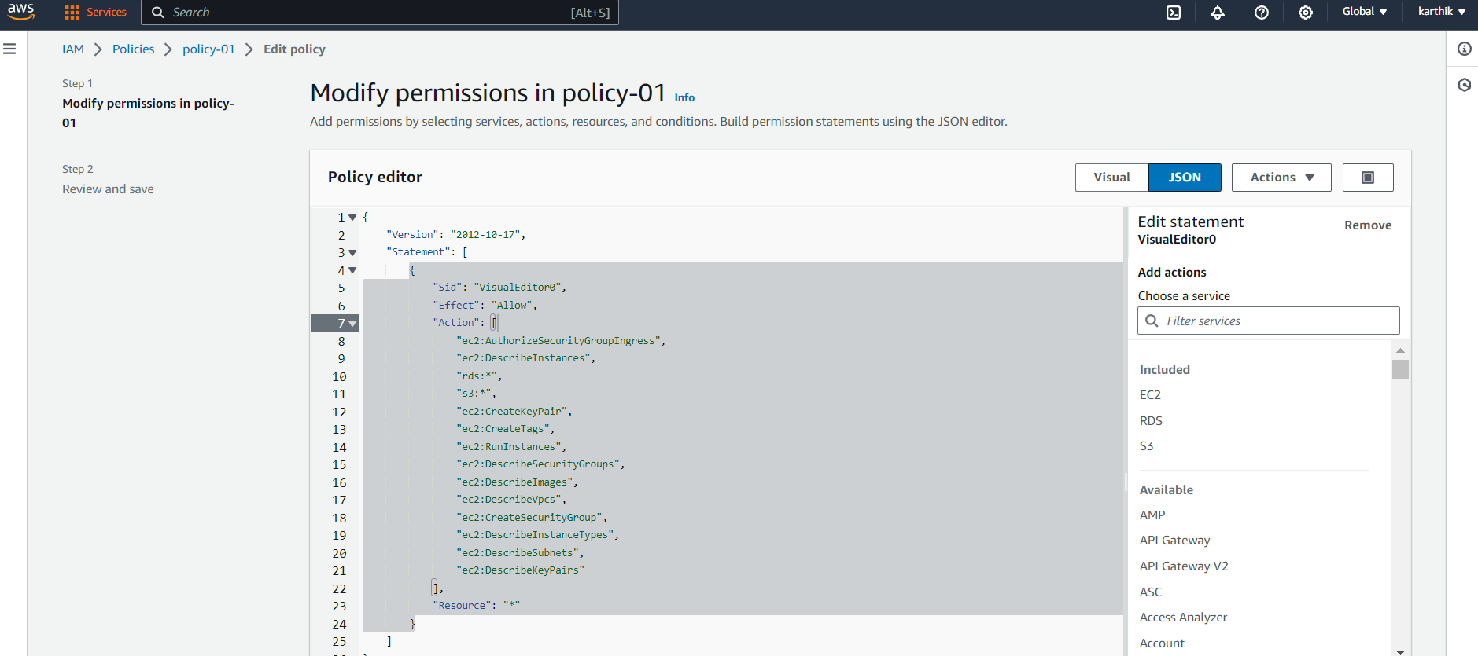

**3. Attached policy number 1 to the Dev Team from task 1**

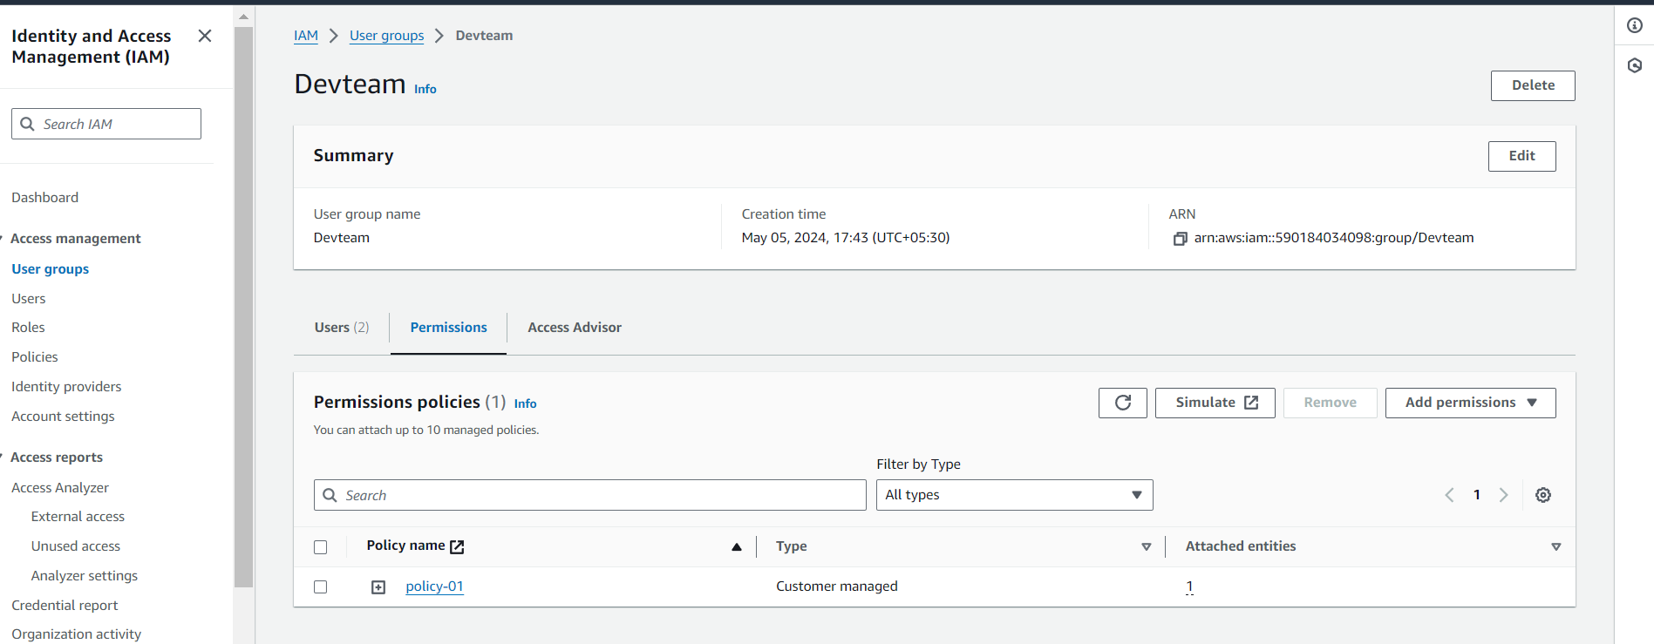

**Created ec2 instance from policy 1**

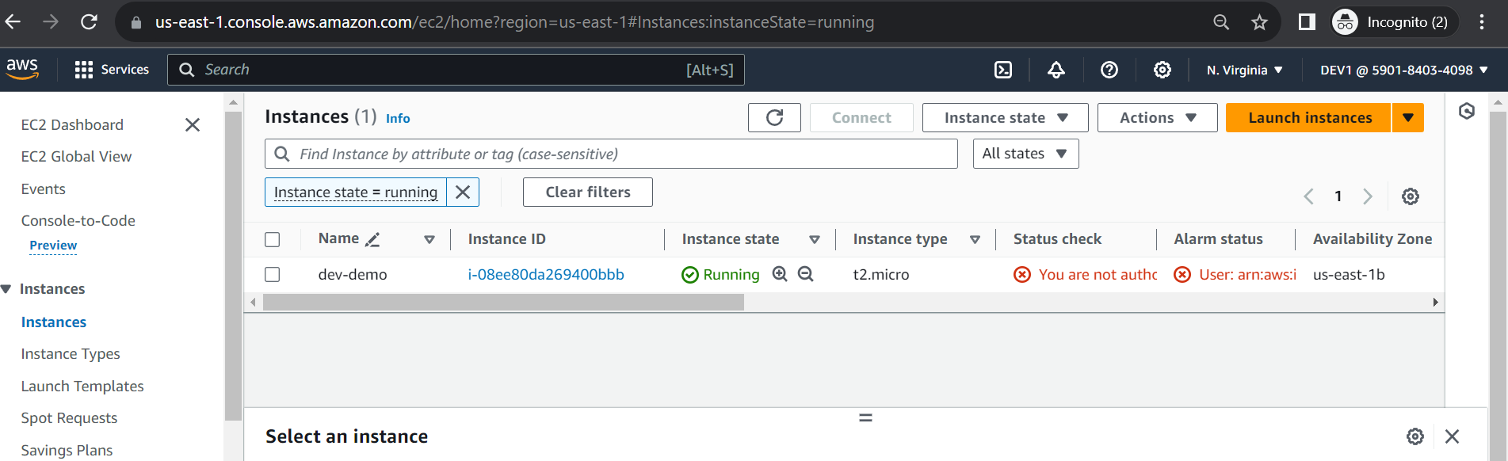

2**. Created a policy number 2 which allows the users to:**

**a. Access CloudWatch and billing completely**

**b. Can only list EC2 and S3 resources**

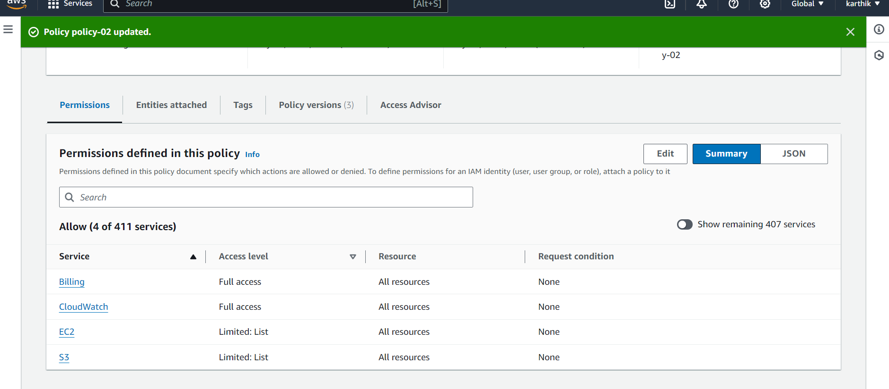

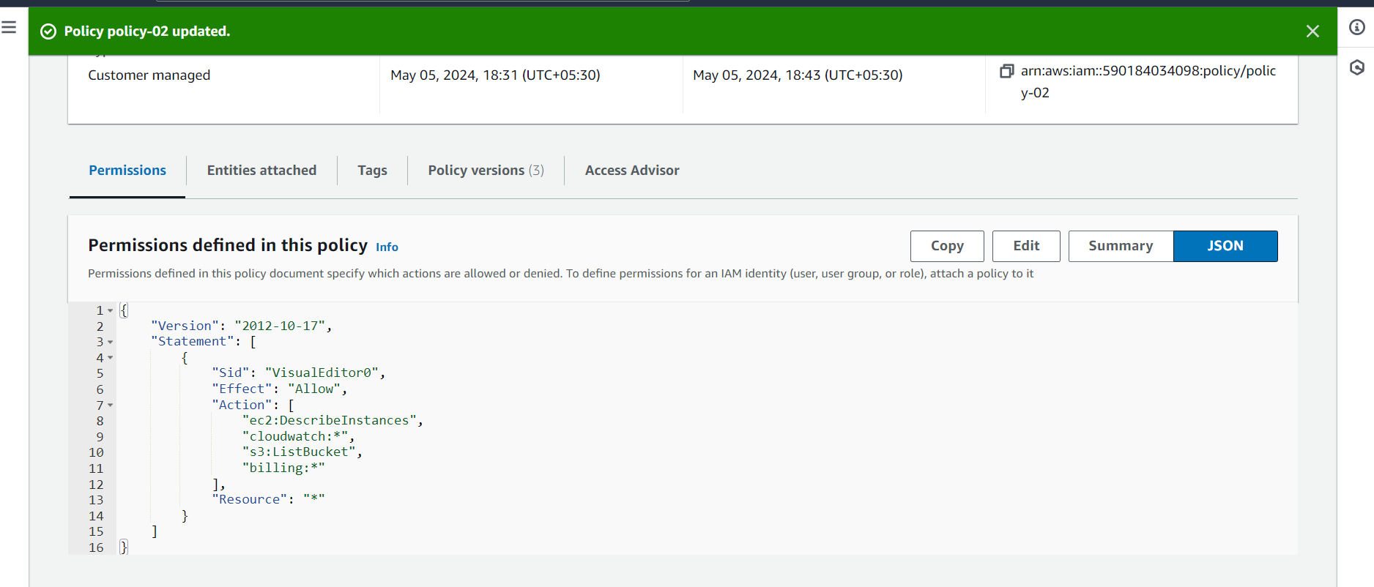

**Attach policy number 2 to Ops Team from task 1**

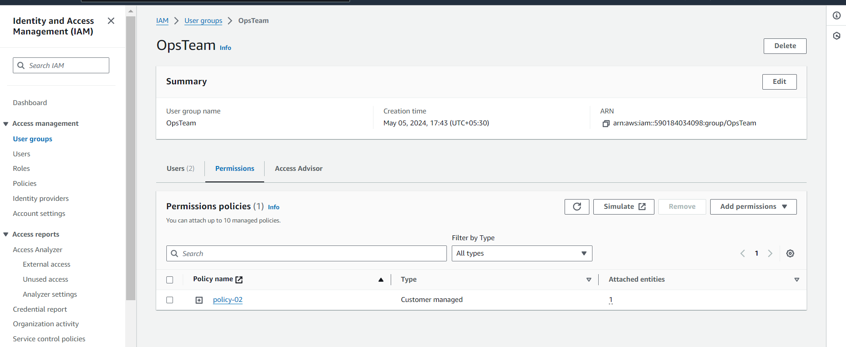

**Created bucket form root access and listed the same in policy02**

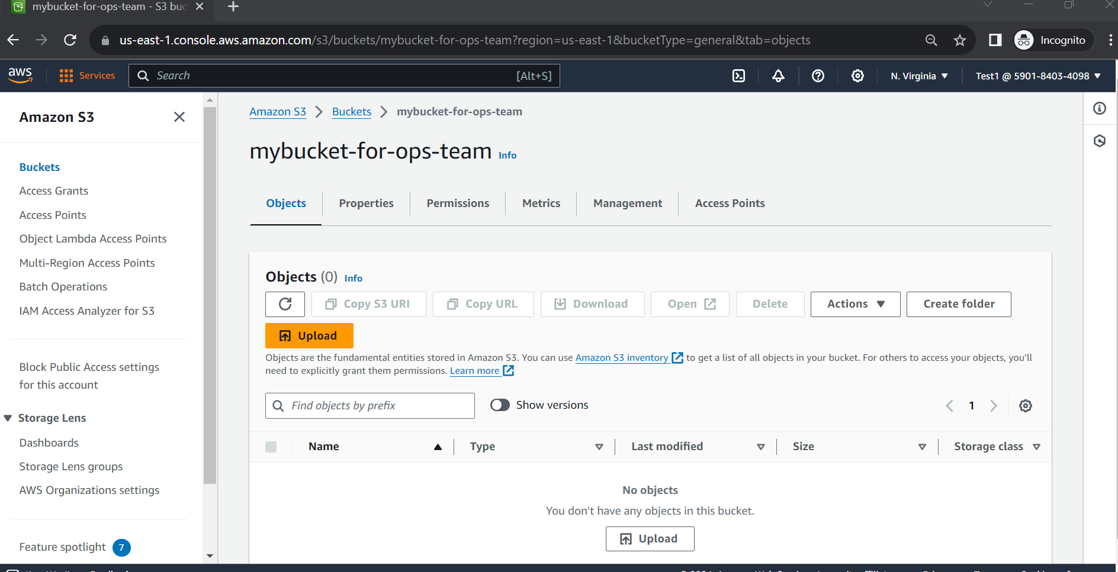

**Listed EC2 from policy 2, it was created using policy-01**

